Parents as Partners Newsletter

February 2026
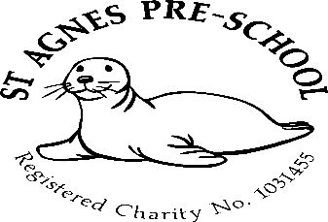

Dates for your diary 2026

Spring term – 6th January to 2nd April 2026
Easter holiday club – 7th to 10th and 13th to 17th April

Summer Term – 20th April to 22nd July
May Day (Preschool closed) Monday 4th May
Half Term – 25th to 29th May (holiday club 26th to 29th)
Last day of term – Wednesday 22nd July
Summer holiday club – (4 weeks) 27th July to 21st August

Autumn term - Monday 7th September to Friday 18th December

1 remaining allocated inset days (Preschool Closed)
23rd July

Entrance
As you will be aware, we have had to temporarily change the entrance through the playground gate, back to the door at the front of the building.
This is because all the rain we have had lately, has caused some flooding and also churned up a lot of mud.
We have had a company in that deals with the said issues and they have said unfortunately, we need a new soakaway. So until this work can be carried out, we will continue to use the entrance at the front.
We are sorry for any inconvenience this may cause!

However, I would like to assure you that the children still have the opportunity to use the outside, as the area we have issues with, has been cordoned off.

St Agnes spring show
Every year, the organisers ask if we could get our 3-4yr olds to make pictures to enter into the St.Agnes Spring show. All children in the Preschool room will be given the opportunity to enter but just to let you know, if a child refuses, we will try to encourage, but cannot force them to take part.
If you want to go along to have a look at your child’s artwork, the date of the show is Saturday 7th March between 1.30-4pm.
Also to say, first names only will be written on the back of each picture, no names will be displayed on the front.
If you don’t have the opportunity to go along, don’t worry, all pictures will be returned to us to send home.

PTO

Holiday clubs
Holiday clubs for Preschool, reception, years 1 and 2 will run over Easter, Summer, and all half terms (excluding the Christmas break and bank holidays)
Booking forms will be available nearer the time of each club.

Easter holiday club
If you would like to book a place for your child, please pick a booking form up from the office or ask a member of staff.

Parents as partners
Just to remind you that as key persons to your children and as members of staff, we are always here for you if you have any queries, suggestions or concerns, so please don’t be afraid to come and talk to us.

Absences
It is a requirement from Ofsted that we make a record of children’s absences from Preschool. Therefore, could we ask that if your child is going to be away, you please ring to let us know. If we don’t hear anything by 10am on the day the child attends, a member of staff is then required to ring up to find out the reason for the absence.

Policies and procedures
The policy for this month is “diet policy and procedure” Please feel free to come to us and discuss anything you’re unsure about.
Should you wish to have a copy of all policies and procedures, please let me know and I will email them to you.

Many thanks,

Mel and team

