Parents as Partners Newsletter
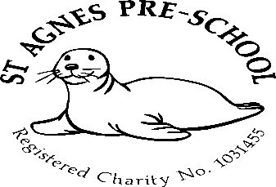

January 2026

Dates for your diary 2026
Spring term – 6th January to 2nd April 2026
February half term – 16th to 20th February
Easter holiday club – 7th to 10th and 13th to 17th April

Summer Term – 20th April to 22nd July
May Day (Preschool closed) Monday 4th May
Half Term – 25th to 29th May (holiday club 26th to 29th)
Last day of term – Wednesday 22nd July
Summer holiday club – (4 weeks) 27th July to 21st August

2 remaining allocated inset days (Preschool Closed) in line with St.Agnes Ace Academy *
23rd February *
23rd July

Holiday clubs
Holiday clubs for Preschool, reception, years 1 and 2 will run over Easter, Summer, and all half terms (excluding the Christmas break and bank holidays)
Booking forms will be available nearer the time of each club.

February half term holiday club
The Wednesday is now full in our half term holiday club with very limited spaces remaining the rest of the week. If you would like to book a place for your child, please pick a booking form up from the office or ask a member of staff.

Breakfast club
Just a gentle reminder for parents of children that attend our breakfast club. If your child requires breakfast in the mornings, could you please ensure that they are here before 8.25am as this is when we stop serving and clear away due to having to set up the Preschool room for the morning session.

Unwell children
Just a gentle reminder to ask that you please keep your child off Preschool if they are unwell. Parents are requested not to bring children into Pre-School who are suffering with infectious diseases or infections- heavy colds, diarrhoea or vomiting (it must be 48 hours from the last episode of diarrhoea or vomiting before they return to the setting). Children who have had to have a dose of any medication to treat a fever, should not then attend the preschool. This is to eliminate the illness spreading through the setting.

Many thanks,

Mel and team

