Parents as Partners Newsletter
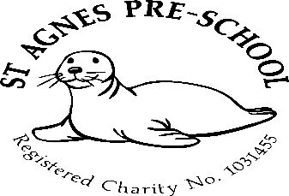

July 2025

Preschool leavers 2025
It’s that time of year again where we have to prepare ourselves to say goodbye to our little Pre-schoolers. It’s always an emotional time for us as we send them on their way to big school. We would like to wish each and every one of them the very best of luck as they leave our Pre-school family to begin the next part of their learning journey. We will certainly miss them very much and we will miss you too!
We hope you all have a great summer!

Dates for your diary
Last day of the Summer term – Tuesday 22nd July
Preschool closed -23rd July

Start of the Autumn term – Thursday 4th September
Half term – 27^{th -} 31st October (holiday club)
Spring Term – 6th January to 2nd April 2026
Half term – 16th to 20th February (holiday club)
Easter holiday 3rd to 17th April
Easter holiday club – 7th to 10th and 13th to 17th April
Summer Term – 20th April to 22nd July
May Day (Preschool closed) Monday 4th May
Half Term – 25th to 29th May (holiday club)
Last day of term – Tuesday 22nd July

5 allocated inset days in line with St.Agnes Ace Academy *
3rd September *
3rd November *
5th January *
23rd February *
23rd July

Parents as partners
Just to remind you that as key persons to your children and as members of staff, we are always here for you if you have any queries, suggestions or concerns, so please don’t be afraid to ask.

Many thanks,

Mel and team

