FAMILY CORNER
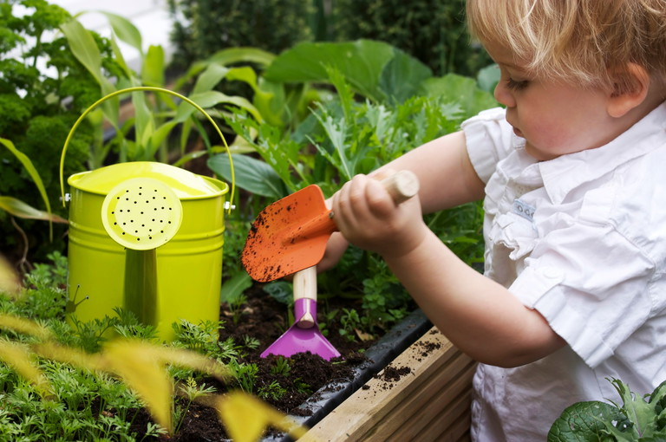

Gardening galore!
We provide a handy guide for getting your little ones out in the fresh air to get stuck in with gardening
*** Share this guidance with your families ***
Gardening is a great activity for all ages – it’s good exercise, it gets us outdoors into the fresh air, and, if you grow your own fruit and veg, it can be a good way to ensure a varied, healthy diet.
Getting young children involved in the garden is not only fun for them – and a lovely way for you to spend time together – but can be an introduction to a hobby that will bring joy and relaxation for the rest of their lives.
You don’t need a huge garden, either – small gardens can be beautiful, and if you don’t have an outdoor space at all, you can get busy growing things in pots and in window boxes.

Buy child-sized gardening tools
If you want your child to get involved in digging and planting, it’s a good idea to invest in some child-sized tools.
You don’t have to spend a fortune; at this time of year, supermarkets have lots of ‘outdoor’ toys, and there’s always some little spades, buckets and trowels in amongst the paddling pools and tennis sets.
The items you most need are a small fork and a trowel, but a small pack of little plant pots can also be fairly cheap and can be filled with your child’s very own plants.

Foodie favourites
Growing your own veg is a fantastic way to encourage both a love of gardening and adventurous eating; your child is more likely to want to try things they’ve grown themselves. Plus, it’s a great way to teach cause and effect so children know the connection between the food they eat and where they come from e.g. apples.
- Courgettes are fairly quick growing, and you get excellent flowers before the fast-growing vegetables appear.
- Pumpkins are hugely satisfying; once they appear, it’s great fun to check on them daily to see them swell and change colour, and they look so fantastic glowing orange in your veg patch.
For both of these, plant the seeds in April after the last frost, and they will be ready by late October. You can start them off in small pots to keep them safe until the plants start to produce leaves, then transfer them to a veg patch.
- Tomatoes, peas and potatoes are also easy to grow and will start to sprout quite quickly.
- Strawberries are a great British fruit and not only look beautiful but taste delicious. It’s best to either buy runners (a green stem that will produce a new plant) or a ready-made plant in a pot.
Invite children to plant their own apple seeds or show them that we can eat strawberry seeds. Encourage your child to investigate seeds from the fruit and vegetables that they eat to compare shape and size.

Tall trees from small seeds
What could be more satisfying to a pre-schooler than growing their very own tree? This is easy to do from an acorn (don’t panic – you won’t end up with a huge oak tree in your garden unless you’re planning to live a very, very long time!).
Collect acorns in early to mid-autumn after the first frost. Remove the cups, soak the acorns overnight in warm water, and sow in compost. You won’t see results until early spring, but after the long, cold winter, it’ll seem like magic to see your own little oak trees appearing.

Bees and butterflies
It’s important to talk to young children about how wildlife such as birds and insects are in decline, and rely on gardens for their survival.
When you and your child plan your gardening together, you can think about the kinds of plants that attract bees and butterflies and even create some wildlife habitats together. The RHS website – rhs.org.uk – is a good source for more information.
You can also use the time together to play games such as I Spy or counting the bees and butterflies.

Safety in the garden
You can use gardening to talk about safety, making your child aware of the dangers of eating and handling some plants – for example, avoiding stinging nettles.
You should also always make sure you and your child wash your hands after handling soil and plants.
Written for the Early Years Alliance by Siobhan Godwood and adapted for Under 5 magazine by Jess Gibson.

