Parents as Partners Newsletter
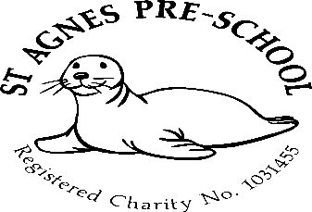

October 2024

We hope that you’ve all had a great summer!

Dates for your diary 2024/2025
Autumn Term 5th September to 20th December 2024
Half term – 28th October – 1st November (holiday club)
Spring Term – 6th January to 4th April 2025
Half term – 17th to 21st February (holiday club)
Easter holiday 7th – 21st April
Easter holiday club – 7th to 11th and 14th to 17th April
Summer Term – 22nd April to 22nd July
May Day (Preschool closed) Monday 5th May
Half Term – 26th to 30th May (holiday club)
Last day of term – Tuesday 22nd July

5 allocated inset days (Preschool Closed) in line with St.Agnes Ace Academy *
3rd and 4th September *
4th November *
24th February *
23rd July

New parents
We would like to welcome you and your lovely children into our already established Preschool family and look forward to caring for and helping them through their learning journey to school. We have an open door policy here so if you have any queries, please feel free to speak to any member of staff, we’re only too happy to help.

Holiday clubs
Holiday clubs for Preschool, reception, years 1 and 2 will run over Easter, Summer, all half terms (excluding the Christmas break and bank holidays)
Booking forms will be available nearer the time of each club.

October half term holiday club
If you would like to book a place for your child in our October holiday club, please ask a member of staff for a booking form.

Staffing
We would like to say a massive congratulations to Andrea, who through all her hard work and determination has gained her Early Years Teacher Status.

Well done Andrea!

Parents as partners
Just a reminder to please check your child’s pigeon hole for any relevant documents or information we may have placed in them.
Just to remind you that as key persons to your children and as members of staff, we are always here for you if you have any queries, suggestions or concerns, so please don’t be afraid to ask.

Family photo board.
We have a family board in the main room displaying pictures of the children with members of their family. If you would like to send in a photo, be it original or photocopy, we will add it to the others where the children will be able to look at and discuss it with their peers. The photo could include parents, siblings, Grandparents etc. We would also be happy to take copies of your pictures here for you.

Labelling
Could we please ask that you label all your child’s belongings including lunch boxes and bottles. This will enable us to return them back to you safely. Unfortunately, we had a lot of lost property left from last term which had to be recycled as it wasn’t collected and it couldn’t be returned as it wasn’t named.

Many thanks,

Mel and team

