Parents as Partners Newsletter
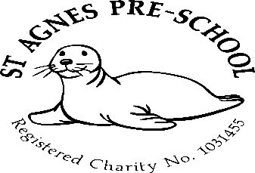

December 2024

We would like to take this opportunity to wish each and every one of you a very Merry Christmas and to say that we look forward to seeing you all again in January.

Dates for your diary 2024/2025
Last day of term - 20th December 2024
Spring Term – 6th January to 4th April 2025
Half term – 17th to 21st February (holiday club)
Easter holiday 7th – 21st April
Easter holiday club – 7th to 11th and 14th to 17th April
Summer Term – 22nd April to 22nd July
May Day (Preschool closed) Monday 5th May
Half Term – 26th to 30th May (holiday club)
Last day of term – Tuesday 22nd July

2 allocated inset days remaining (Preschool Closed) in line with St.Agnes Ace Academy *
24th February *
23rd July

Unwell children
Just a gentle reminder to ask that you please keep your child off Preschool if they are unwell. Parents are requested not to bring children into Pre-School who are suffering with infectious diseases or infections- heavy colds or diarrhoea or vomiting (it must be 48 hours from the last episode of diarrhoea or vomiting before they return to the setting). Children who have had to have a dose of any medication to treat a fever, should not then attend the preschool. This is to eliminate the illness spreading through the setting.

Eating food when entering the setting
Could we please ask you not to bring your child into Preschool while they are eating. We have had a few instances where children are walking around with food in their mouths which isn’t good practice.
Just to let you know, the children are served snack at 10am.

Fundraising
Some of the things bought with money raised at the latest fundraising events.
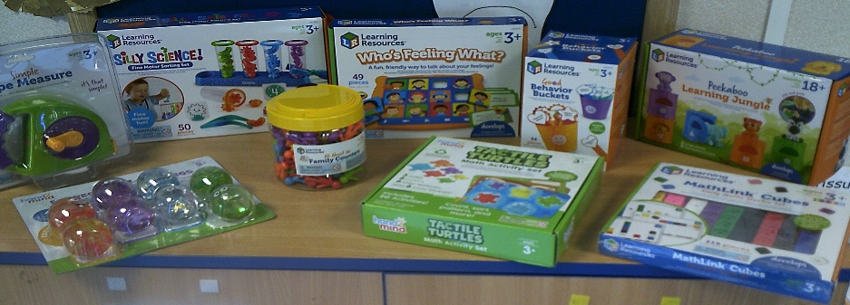


We would like to say a massive thank you to all involved from organising the events to supporting them, as without you we wouldn’t have been able to purchase it all.

Drop off/pick up
We would very much appreciate it if you would please drop off/pick up your child/children promptly at the beginning and end of each session. Late arrivals often cause disruption as a member of staff has to leave an activity that they are doing with their group of children to go and answer the door. Children also settle better when they arrive at the same time as their friends. They can also miss important discussions at registration too. late pick ups also have an impact on lunchtime routines and after school club.
Thank you in advance for your cooperation.
Toys from home
Please could I ask that do not send your child into Preschool with toys from home.
We are having a few issues with toys getting lost, taken and broken, which is causing squabbles and also children to become upset.

Policies and produces
The policy for this month is “sick children” Please feel free to come and discuss anything you’re unsure about with Mel.
A copy of all policies and procedures are kept in the entrance hall for you to read.
Should you wish to have a copy of these, please let me know and I will email them to you.

Holiday clubs
The next holiday club will be in February half term.

Holiday clubs for Preschool, reception, years 1 and 2 will run over Easter, Summer and all half terms (excluding the Christmas break and bank holidays)
Booking forms will be available nearer the time of each club.

Parents as partners
Just to remind you that as key persons to your children and as members of staff, we are always here for you if you have any queries, suggestions or concerns, so please don’t be afraid to ask.

Spare change of clothing
Could you please send a bag into Preschool with a spare change of clothes for your child. This is not only in case of toileting accidents, but also for water play etc.
Also, for children in nappies, could you please include nappy cream in your child’s changing bag as we cannot keep a supply here due to cross contamination.

Absences
It is a requirement from Ofsted that we make a record of children’s absences from Preschool. Therefore, could we ask that if your child is going to be away, you please ring us to let us know. If we don’t hear anything by 10am on the day the child attends, a member of staff is then required to ring up to find out the reason for the absence.

Many thanks,

Mel and team

