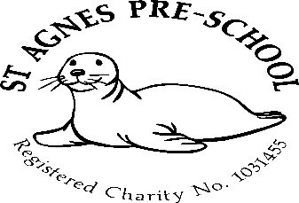


Dear Parent.
Now the warmer weather is on its way we are starting to introduce our sun safety measures.
Drinks bottle
If you don’t already, could you please send a named drinks bottle into Preschool daily so we can keep it out on the side. This will enable us to monitor the amount of fluid the children take in.
Sun cream
We are asking that before bringing your child into Preschool, you please apply their sun cream. We will reapply it to the children that stay all day after lunch, so for those children, could you please put spare sun cream in their bags with their name on it and could you also please include a sun hat.
Please note, we do not keep spare sun cream at the Preschool.
We would like to reassure you that when it becomes very hot, we do limit our time outside.
Lunch bags
Due to the number of children having packed lunch, we are unable to store their lunch bags in the fridge, so could you please enclose a little ice pack into your child’s packed lunch, this will ensure it stays cool until lunchtime
Many thanks
Lisa and team
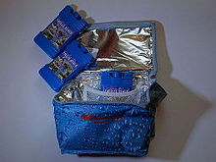



Sun protection Policy and Procedure

At St Agnes pre-school we want staff and children to enjoy the sun safely. We will work with staff and parents to achieve this through:
EDUCATION – these measures are in place from now on:
- All children will have a Sun awareness story time at the start of the summer term.
- All children will paint sun smart pictures to re-enforce the sun protection messages.
- Parents and guardians will be sent a letter explaining what we are doing about sun protection and how they can help at the beginning of the summer term.
- We include sun protection awareness training at staff meetings.

PROTECTION – this is more of an ongoing process which involves:
Shade:
We will use the shade provided eg: tents and Den building when playing and having snack and story time outside.
Timetabling:
Children will not be allowed outside for long periods of time during the hours of 11am and 3pm. Although outside free flow is encouraged the sun exposure will be noted and monitored – especially for those children attending a whole day.
Clothing:
Important
We are also actively encouraging the children to wear a hat when they play outside. Please send your child to pre-school wearing a comfortable wide brimmed hat or legionnaire style cap

Sunscreen:
We ask parents:-to apply sunscreen before the child arrives at pre-school
We require parents to give permission for staff to supervise the applying of sunscreen which they have provided. Children will need to bring in their own labelled bottle of sunscreen
We will also provide fresh water outside at all times as we recognise that playing outside can make the children thirsty.

