Parents as Partners Newsletter
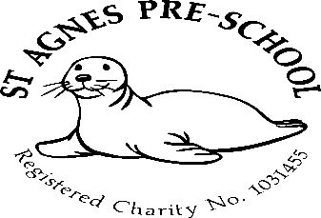

May 2024

Dates for your diary
Summer Term – 15th April to 23rd July
Half Term – 27th to 31st May
Last day of the summer term – Tuesday 23th July
Start of the Autumn term – Thursday 5th September

2 remaining allocated Inset days (Preschool Closed) *in line with St.Agnes Ace Academy
10th June *
24th July

Holiday club
There are still a few spaces left in the May half term holiday club. Please ask a member of staff for a booking form if you wish to book a place for your child.

The next holiday club will be the summer club.
This will run for 4 weeks from Monday 29th July to Friday 23rd August and booking forms for that will be available at the beginning of June.

Places will be allocated on a first come first serve basis as there will be limited spaces available.

Parents as partners
Just to remind you that as key persons to your children and as members of staff, we are always here for you if you have any queries, suggestions or concerns, so please don’t be afraid to ask.

Breakfast club
Just a gentle reminder for parents of children that attend our breakfast club. If your child requires breakfast in the mornings, could you please ensure that they are here before 8.30am as this is when we stop serving and clear away due to having to set up the Preschool room for the morning session.

Suitable clothing
Could we please ask you not to send your child into Preschool with all in one clothing on, children are finding it difficult to use the toilet while wearing it and for children in nappies, staff have to remove it all when the nappy needs changing.
Dress up outfits are also becoming an issue where long dresses, capes etc are becoming entangled in the wheels of the ride on toys and also a tripping hazard when using the steps of the playhouse/climbing frame. Children also tend to “act the part” – which in turn can lead to unsuitable behaviour. They also find it difficult to manage when having to use the toilet.

Spare clothing
As the weather has started to get a little warmer, we are introducing more water play activities, so could we please ask that you send in a labelled bag of spare clothes with your child, this would also so be for messy play and toileting accidents etc. We do stock a few spare items but these tend to run low and some children are quite particular about what they put on and will only wear their own from home.

Labelling
Could we please ask that you label all your child’s belongings including clothing, lunch boxes and bottles. This will enable us to return them back to you safely.

Policies and procedures
The policy for this month is “Sun safety” Please feel free to come and discuss anything you’re unsure about with Mel.
A copy of all policies and procedures are kept in the entrance hall for you to read.
Should you wish to have a copy of these, please let me know and I will email them to you.

Many thanks,

Mel and team

