Parents as Partners Newsletter
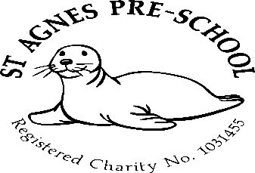

February 2024

Dates for your diary
Spring Term – 4th January to 28th March
Half term – 12th to 16th February
Easter holiday club – 2nd to 5th and 8th to 12th April
Summer Term – 15th April to 23rd July
May Day (Preschool closed) Monday 6th May
Half Term – 27th to 31st May
Last day of the summer term – Tuesday 23th July

3 remaining allocated Inset days (Preschool Closed) in line with *St.Agnes Ace Academy
19th February *
10th June *
24th July

February half term holiday club
The cut off date for booking places in the holiday club has now passed.
The next holiday club (numbers of children permitting) will take place over Easter. (Details to follow)

Fundraising


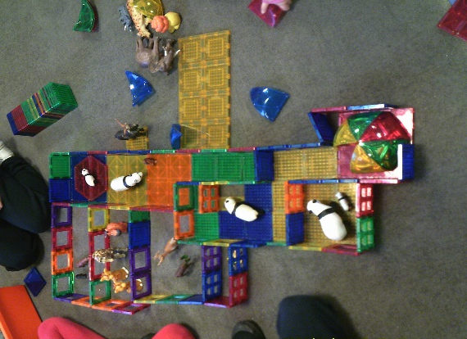

Last Octobers amazing fundraising event made a grand total of £288.95 and this is what we bought.

It’s a high quality magnetic construction set that the children absolutely love.

We would again like to thank all involved from organising the event to supporting it, as without you we wouldn’t have been able to purchase it.

Breakfast club
Just a gentle reminder for parents of children that attend our breakfast club. If your child requires breakfast in the mornings, could you please ensure that they are here before 8.30am as this is when we stop serving and clear away due to having to set up the Preschool room for the morning session.

Funding
All early years settings have been asked by the DfE (Department for Education) to provide you with some information regarding Funding.
From 2 January 2024, eligible working parents can apply for 15 hours of childcare for their two-year-old. Parents have until 31 March 2024 to apply for a code, with mid-January to the end of February being the optimum time to apply in case they need to provide further information to support their application.
To apply for a childcare code each parent needs to be working and earning the equivalent of 16 hours a week at national minimum/living wage and under £100,000 adjusted net income per year. This means that each parent needs to earn from just over £8,600 per year to be eligible for 15 hours a week of childcare during term time.
Your child will be funded from April 2024
There is more information on the childcare support available to parents on the Childcare Choices website where you can explore the early education entitlements and other government help with childcare costs.
Unwell children
Just a gentle reminder to ask that you please keep your child off Preschool if they are unwell. Unfortunately, we had to close our two year old room for 2 days recently due to staff illness!
Parents are requested not to bring children into Pre-School who are suffering with infectious diseases or infections- heavy colds, diarrhoea or vomiting (it must be 48 hours from the last episode of diarrhoea or vomiting before they return to the setting). Children who have had to have a dose of any medication to treat a fever, should not then attend the preschool. This is to eliminate the illness spreading through the setting.

Parents as partners
Just to remind you that as key persons to your children and as members of staff, we are always here for you if you have any queries, suggestions or concerns, so please don’t be afraid to ask.

Labelling
Could we please ask that you label all your child’s belongings including lunch boxes and bottles. This will enable us to return them back to you safely.

Policies and produces
The policy for this month is “working in partnership with other agencies” Please feel free to come and discuss anything you’re unsure about with Mel.
A copy of all policies and procedures are kept in the entrance hall for you to read.
Should you wish to have a copy of these, please let me know and I will email them to you.

Many thanks,

Mel and team

