Parents as Partners Newsletter
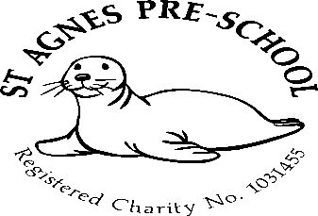

December 2023

We would like to take this opportunity to wish each and every one of you a very Merry Christmas and to say that we look forward to seeing you all again in January.

Dates for your diary
Autumn Term 6th September to 19th December
Spring Term – 4th January to 28th March
Half term – 12th to 16th February
Easter holiday club – 2nd to 5th and 8th to 12th April
Summer Term – 15th April to 23rd July
May Day (Preschool closed) Monday 6th May
Half Term – 27th to 31st May
Last day of the summer term – Tuesday 23th July

Last day of term
Just to remind you that we break up on Tuesday 19th December for the Christmas holidays and
return again on Thursday 4th January 2024.

3 remaining allocated Inset days (Preschool Closed) in line with *St.Agnes Ace Academy
19th February *
10th June *
24th July

Absences
It is a requirement from Ofsted that we make a record of children’s absences from Preschool. Therefore, could we ask that if your child is going to be away, you please ring us to let us know. If we don’t hear anything by 10am on the day the child attends, a member of staff is then required to ring up to find out the reason for the absence.

Sick children
We are still having a small number of children brought into Preschool that are unwell. Could we please ask that you keep your child at home if they have a persistent cough or heavy cold etc. If your child has had to have calpol they must stay at home. Unwell children have a knock on effect when they attend the setting. We have to have a certain amount of staff to numbers of children to be able to open, so if we have too many members of staff go off at the same time because of illness, we would have to close some of the Preschool sessions.

Packed Lunch
Just a reminder to say that when sending in packed lunches, could I please ask that you include a named drinks bottle and also a cool block as lunch boxes are not refrigerated and left out longer than the 2 hour safety guideline.

Parents as partners
Just to remind you that as key persons to your children and as members of staff, we are always here for you if you have any queries, suggestions or concerns, so please don’t be afraid to ask.

Labelling
Could you please label all your child’s belongings including lunch boxes and bottles. This will enable us to return them back to you.

Topic
The topic for the rest of this term is “celebrations” We have already covered this topic through a wide range of activities including Diwali and over the last few weeks we will be covering Hanukah, Christmas and birthdays etc.

Policies and produces
The policy for this month is “adverse weather” Please feel free to come and discuss anything you’re unsure about with Mel.
A copy of all policies and procedures are kept in the entrance hall for you to read.
Should you wish to have a copy of these, please let me know and I will email them to you.

Many thanks,

Mel and team

