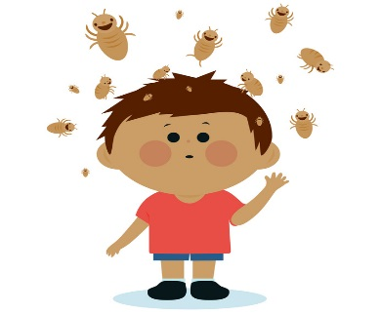
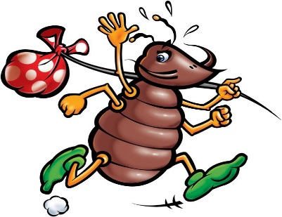
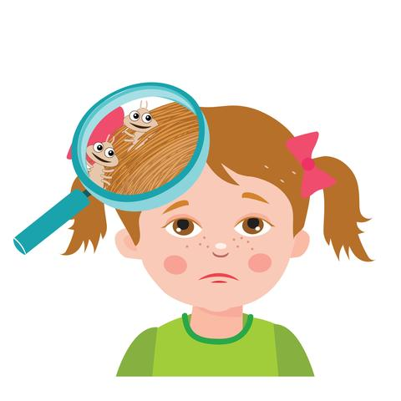

Head lice

How do you catch them?

Head lice are small grey or brown wingless insects about the size of a grain of rice when fully grown. You can only catch head lice by having close (head to head) contact with someone who already has them.

The eggs (nits) are very small and dull in colour and are found close to the scalp
cemented onto the hair. Empty egg cases are white and shiny and may be found further along the hair shaft, as the hair grows out. It is very difficult to comb these out. A louse takes 7- 10 days to become fully grown. Only adult lice lay eggs, so once treatment has started you are not infectious.

Remember,
Head lice DO NOT jump, fly or swim but they can walk quickly from head to head.

Anyone can catch head lice. We recommend that everyone in the family should be checked weekly as a routine, it could be the only way to find them. Head lice may not cause itching.
Comb wet conditioned hair from roots to tips in sections using the detector comb as near to the scalp as possible. If live lice are found then follow
Option One - insecticide or Option Two - Conditioner (or a combination of both)
Remember also to check the heads of all close contacts (family members, very close friends)
Never use insecticide to prevent infection, or just in case.

OPTION ONE - TREATMENT WITH LOTION.
Use lotions only if living lice are found.
Recommended insecticides are:
PHENOTHRIN (FULL MARKS)
PERMETHRIN (LYCLEAR)
MALATHION (DERBAC M)
1. Apply lotion according to the manufacturer’s instructions. DO NOT use hair conditioners with the lotion (including 2 in 1 shampoos)
2. Comb hair carefully with a detector comb immediately after treatment.
3. Repeat combing (with conditioner) every 3 days for 14 days to remove any lice emerging from eggs.
4. Repeat the lotion after 7 days (steps 1 and 2)
5. If lice are found at the end of this 14 day period, apply a different insecticide lotion again or option two. Repeat steps 1 to 3.
6. After this, if you still find lice, a two week insecticidal free period is recommended.
Continue to condition and comb every other day and check all the contacts again.

OPTION TWO - "WET-COMBING" METHOD
1. After washing hair use plenty of hair conditioner, brush or comb through first to get rid of tangles.
2. Carefully comb sections of hair from scalp to tip using a ‘nit’ comb. Inspect the comb for lice after every section, removing them before combing through the next section.
3. After combing the whole head, the hair conditioner should be rinsed off, and then repeat the combing with the detector comb.
4. Repeat this every 3 days for 2 weeks. You may still find immature lice for up to 10 days, do not worry.

If the above regime does not cure the infection, CARBARYL (only available from your Family Doctor) may be used, combined with the same combing treatment. Seek medical advice for babies under 6 months, during pregnancy or if suffering from asthma.

