FAMILY CORNER

Check on your child's MMR

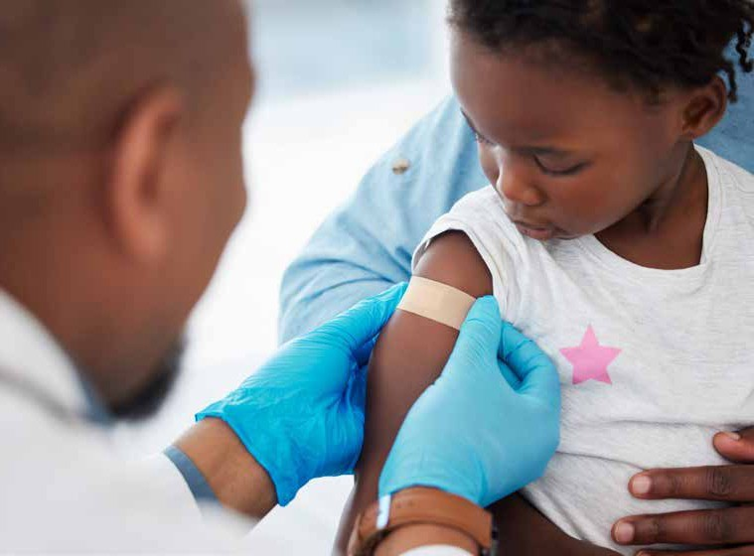
As cases of measles are on the rise, the UKHSA is asking families with young children to check their MMR records. Here’s what you need to know

Share this guidance with your families
UK Health Security Agency (UKHSA) is urging families with young children, teenagers and adults to ensure that they are up to date with their measles, mumps, and rubella (MMR) vaccines to address the rising measles cases in the UK.
According to recent data published by the UKHSA, there has been a concerning increase in measles cases in the UK between January and April of this year. As of 20 April, there were 49 cases reported, compared to the 54 cases reported throughout the entire year of 2022.
While the majority of cases have been concentrated in London, there have been reported cases across the country, some of which have been linked to travel abroad.
Measles is a highly infectious disease that can lead to severe health complications such as pneumonia, meningitis, and, in rare cases, long-term disability or death. Symptoms include a high fever, sore red watery eyes, and a blotchy red-brown rash, and it is particularly easy to catch in crowded environments. Recent years have seen a decline in the number of children receiving the MMR vaccine, with only 89% of children in England receiving the first dose by the age of two, and 85% receiving both doses by the age of five. These rates are well below the World Health Organization’s (WHO’s) recommended target of 95% for achieving and maintaining the elimination of measles.
Dr Vanessa Saliba, Consultant Epidemiologist at UKHSA, said “We are calling on all parents and guardians to make sure their children are up to date with their 2 MMR doses. It’s never too late to catch up, and you can get the MMR vaccine for free on the NHS whatever your age. Vaccines are our best line of defence against diseases like measles, mumps and rubella and help stop outbreaks occurring in the community.”

What is measles?
Measles is an infection that spreads very easily. It can cause serious complications, such as pneumonia and meningitis, and in rare cases, can lead to long-term disability or death.

How can I check if my child has had their MMR vaccine doses?
It’s important to catch up on any missed vaccines. If your child has not received the MMR vaccine, or if you are unsure if they have received both doses, you should contact your GP practice to arrange for them to receive the vaccine. It is never too late to catch up on missed vaccinations, even if your child is older than the recommended age.

Is the MMR vaccine safe?
It is important to note that there is no scientific evidence to support claims that the MMR vaccine is linked to autism. The MMR vaccine has been extensively tested and has been proven to be safe and effective.

