Family corner

Teaching children kindness
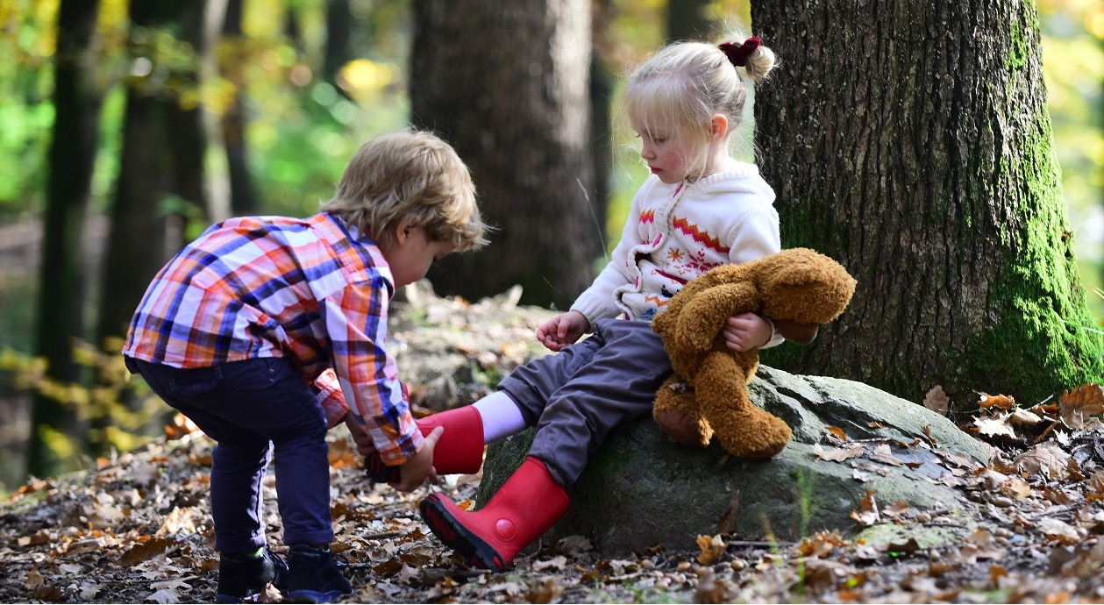
With children facing a range of challenges such as bullying, loneliness or discrimination, the positive effects of teaching kindness can be huge. The act of being friendly, generous, and considerate costs nothing, but the impact of kindness on an individual can be immense.
Not only does being kind affect how we feel but being treated kindly can have positive physical benefits too – hormones are released, stress levels are lowered, mood is enhanced and anxiety and depression improves.
Creating a kinder world
So how can we build on this to create a truly a kinder world? By teaching our young children to be kind from day one. And the best way to teach them is to show them by being kind ourselves. We are our children’s most important influence and they will see and absorb everything we do — from how we treat other family members to action we take in our communities to help others.
Being kind to others and doing nice things for them is a great opportunity to teach your child about politeness, courtesy, empathy and selflessness because you don’t expect anything in return.
Making a difference
The Random Acts of Kindness Foundation has commissioned several surveys into the impact of kindness and found that teaching it in early years and school settings can make a difference to children’s attitudes and approaches to others. The research found that children were better behaved and more disciplined when they considered the feelings of others and were more inclusive in their play and interactions.
Talking about kindness and thinking of ways to be kind to others is a great opportunity to do something together with your child. It might be checking in on a neighbour you haven’t seen for a while, making something for a friend — or even doing something nice for a sibling for no reason!

Creative ways for kindness
Here are a few tips on how acts of kindness can give you and your little one that warm feeling:-
Smile at passers-by in the street and greet them with a ‘hello’ or ‘good morning’
Hold open doors for people, especially if they’re struggling with buggies or heavy shopping.
Surprise a friend or relative with a handwritten card or letter asking how they are.
When heading to the shops, ask a neighbour if they need anything to save them having to go out.
Make more effort with the child who finds it hard to make friends. A play date or invitation to the park will brighten theirs and their parents’ day.

Praise your child for the kind things they did and explain how they made someone else’s day a little bit better. See if they can think of ways others were kind to them and ask how it made them feel.

